ECE322 Lab

Lab 2 Report
Part 1: Activity 1

Jason Yan

9/10/26 8:00 am

Contents

1. Amplifier test fixture schematic 1
2. DC sweep and gain region analysis 2
3. Spice transient from part D 3
4. FFT result from part E 4
5. Plot from Part F 5
6. Transient from Part G 6
7. FFT from Part G
8. Observations

Amplifier test fixture schematic
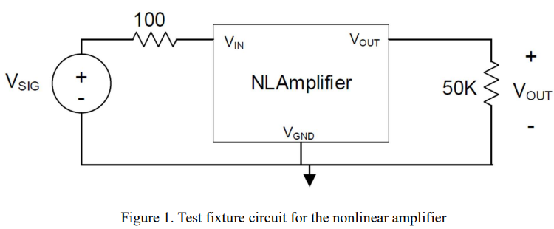

2. DC sweep and gain region analysis

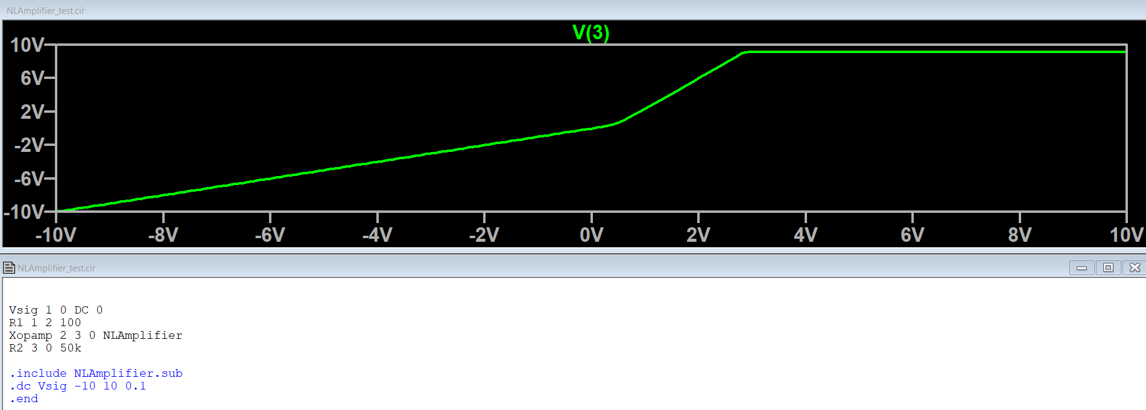
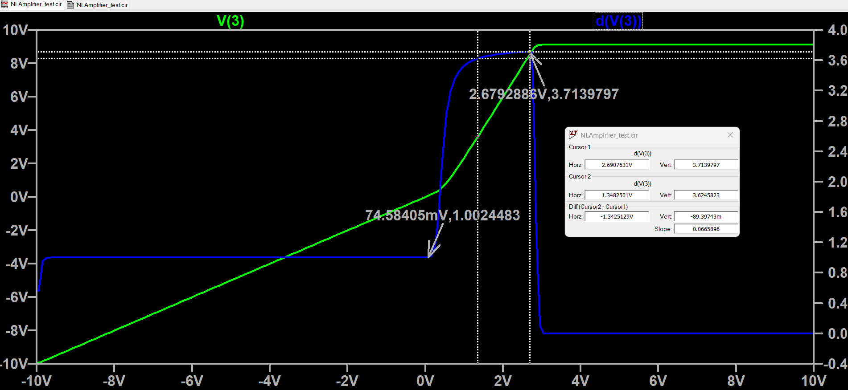
Input Bias for DC sin (midpnt) = 2.02
input signal swing amplitude=.67
the cursors show my selected region for the gain sin signal

3. Spice transient from part D
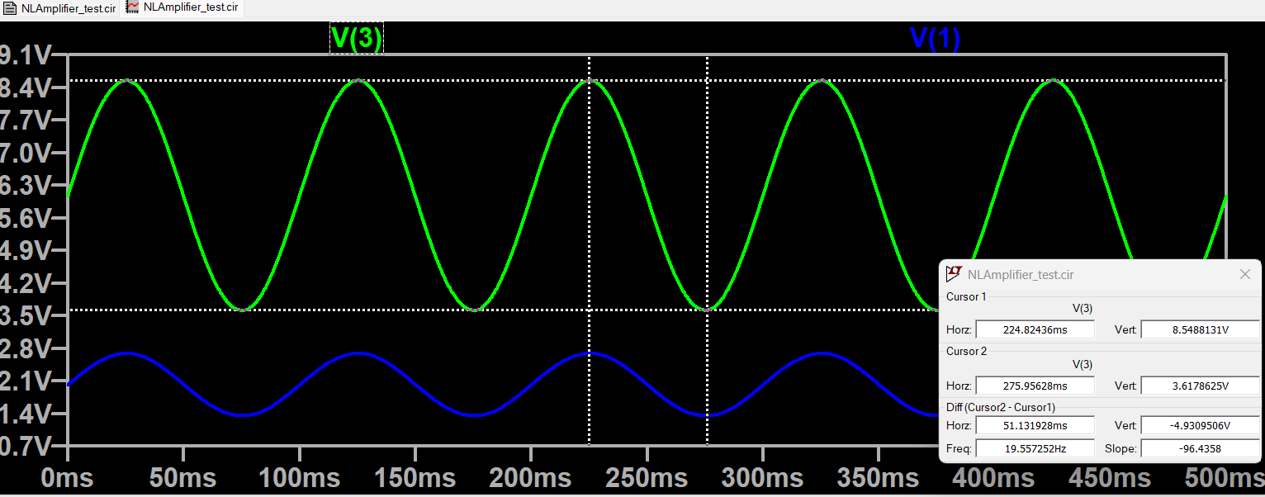
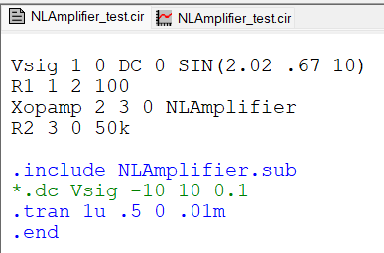

4. FFT result from part E
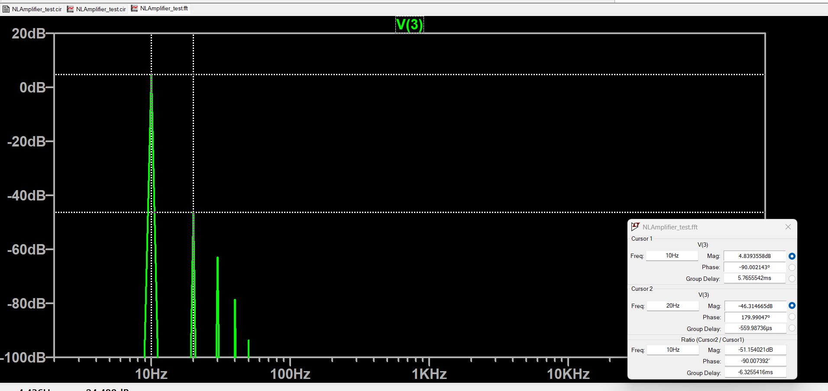
My harmonic components sit around 50dB below fundamental
Compared to the distortion free FFT, my harmonic components are a bit larger than one without distortion, likely meaning my signal has a decent amount of distortion. (smaller difference between the 2 peaks results in less distortion)

5. Plot from Part F
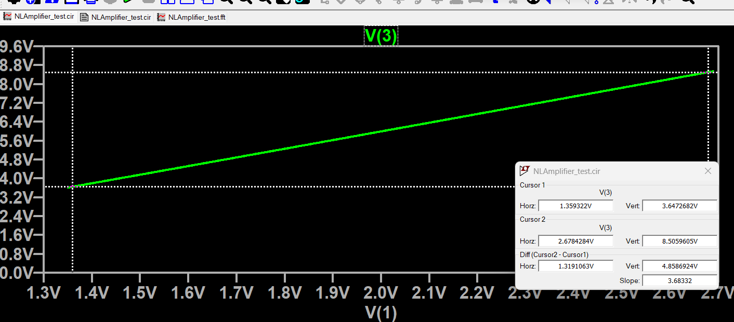
From part B, I characterized my sin signal around 1.34V to 2.7V, which matches the range of my gain of 1.3V to 2.67V.

6. Transient from Part G
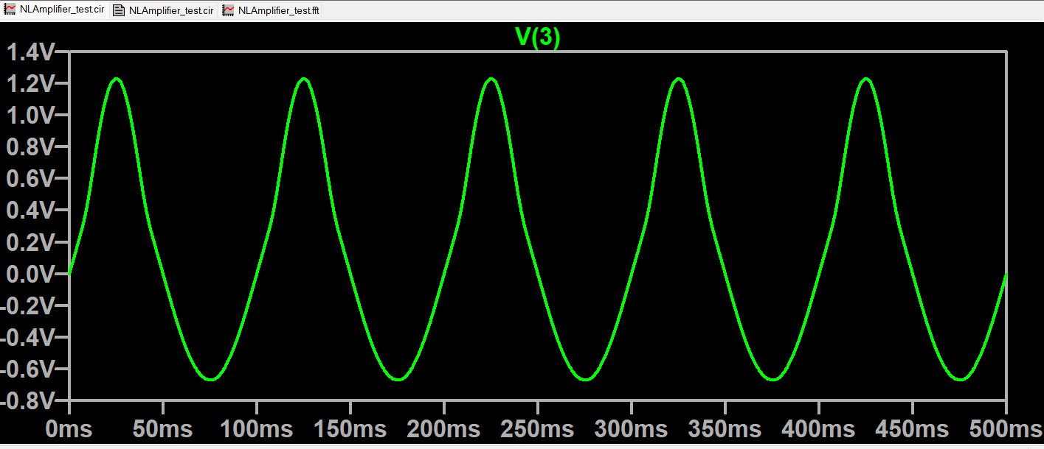

7. FFT from Part G
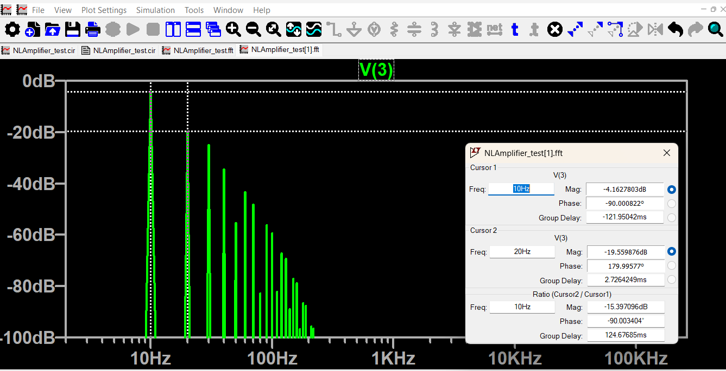

8. Observations
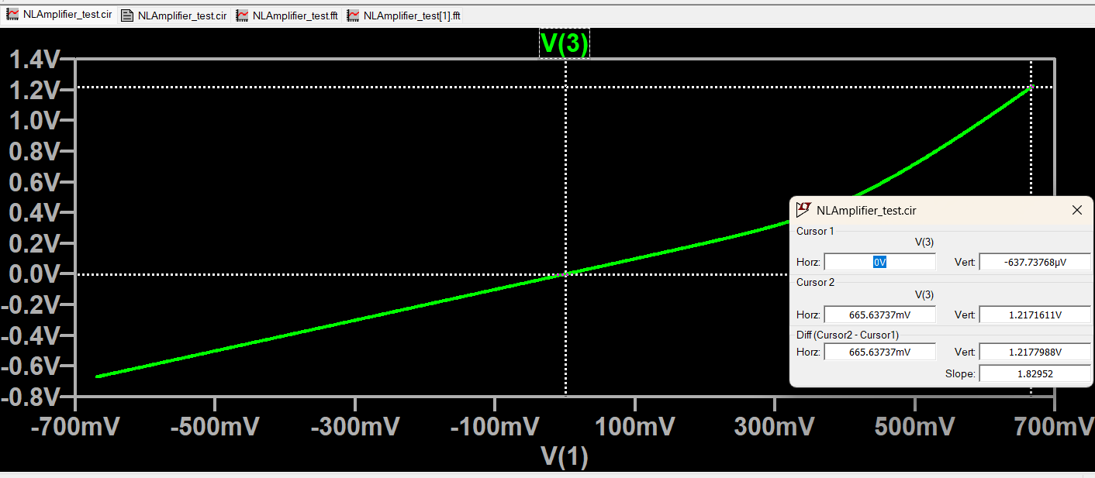
After setting the bias point to 0, I noticed that my sin Vout signal was heavily distorted at the bottom, the FFT reflects this with a harmonic component only -15dB below the fundamental, where -80dB should be standard for low distortion. This likely means that the 0 bias signal has a huge amount of distortion, and this is reflected in the gain chart with a very non-linear gain graph.

